# COMPS313F Mobile Application Programming

## Project in Mobile Application Development

Group information:

Application name: Weather App

Member list:

Lam Ho 12543046

Kon Yuen Lam 12669130

Ling Tsz Wo 12539518

Wong Lam 12599287

### Description of the details about the design, implementation and evaluation of your application.

For our Weather Application, we mainly focus to provide brief information of the weather to the user, like today's temperature,weather, humidity.So Users know whether the weather in their area is good or bad. And we hope our application is concise, so users will not feel confused if there not so much information needs to read. We will make the important information text highlight or bold and some minor information will be smaller.

We decided to use React Native to develop our Mobile App because React Native is great for mobile apps. It provides a slick, smooth, and responsive user interface, while significantly reducing load time. It’s also much faster and cheaper to build apps in React Native as opposed to building native ones, without the need to compromise on quality and functionality.Also, React Native is based on JavaScript,the syntax is very easy to write and read.So we don’t need so much time to learn or get to grips with it. And React Native can develop cross-platform applications like IOS,Android,macOS, Web, and Windows.So it can “Write Once, Run Everywhere”.So different platform users all can use our application.

And we use the openweather website’s API for requesting weather information. https://openweathermap.org/api

After we handle all JSON format weather data that the website returned, then we transform it and put it in the place we want in the application.

For evaluation of the application, we find some people to try and run the application.Most the people say application runs smooth and there has error handling when the user input not valid city name and it will have a notification to remind the user the city name not found/not valid. However, the background image sometimes will block the text of the weather information or make the text not that conspicuous.It makes users need more time to read the text.

To use React Native to develop a Mobile App, we need to install Android Studio and Node.js first to use React Native.After that…

1)In CMD , Change the current directory to the newly created on with command “cd”

* + E.g. cd c:\react-native-project

2)Create React Native project with the following command

“npx react-native init Groupproject”

You don’t have to do it if you have our application’s file

3)Change the current directory to the project directory

* + Type command
    - E.g “cd Groupproject”

4) : Install and launch the app on device

* + Type command
    - “npx react-native run-android”

Note:You need install the dependencies before run our application

“npm i redux redux-thunk react-redux” type the command in the terminal .

### Description of the major and significant feature or improvement of your application.

For improvement of the application, some feedback says the background image sometimes will block the text of the weather information or make the text not that conspicuous. So we don’t use any background image and use white/grey background color to replace it and the text in the application uses black color. It can make it easier to deliver information to users easier and the text will more conspicuous in white/grey background color.

It is initial screen

Input Hong Kong and show the information

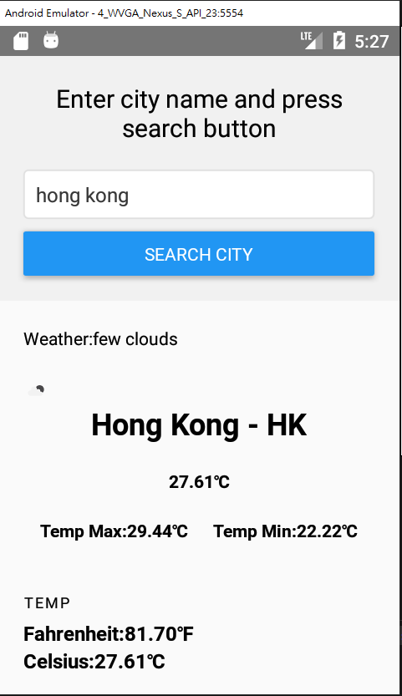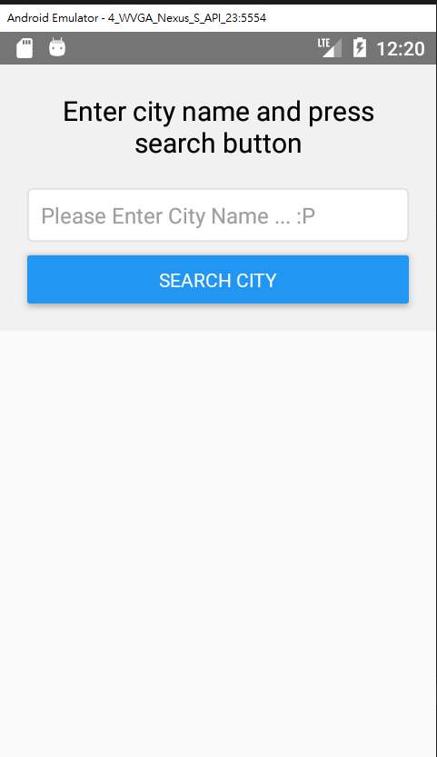

After input the city name ,user can press the “search city” button

Search bar for user to input city name they want

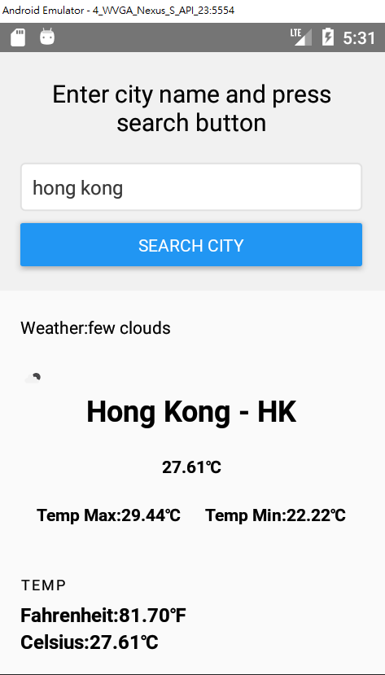

City/Country name and the short form

An image to represent the weather situation

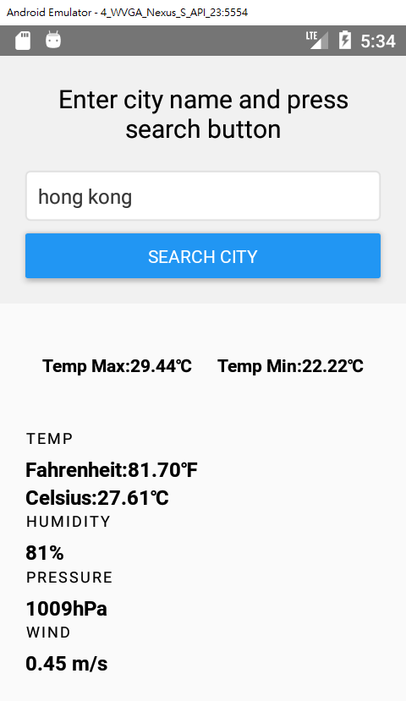

Weather information